CREATE TABLE table_a (id INT, name VARCHAR(50) );

CREATE TABLE table_b (id INT, color VARCHAR(50));

INSERT INTO table_a VALUES (1, 'apple');

INSERT INTO table_a VALUES (1, 'apple');

INSERT INTO table_a VALUES (1, 'apple');

INSERT INTO table_a VALUES (1, 'apple');

INSERT INTO table_a VALUES (2, 'Banana');

INSERT INTO table_a VALUES (2, 'Banana');

INSERT INTO table_a VALUES (3, 'Guava');

INSERT INTO table_b VALUES (1, 'Red');

INSERT INTO table_b VALUES (2, 'Yellow');

INSERT INTO table_b VALUES (3, 'Green');

1. LEFT JOIN:

SELECT table_a.id, table_a.name, table_b.color

FROM table_a

LEFT JOIN table_b ON table_a.id = table_b.id;

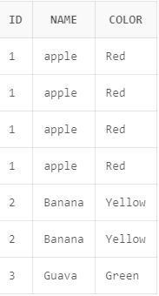

2. RIGHT JOIN

SELECT table_a.id, table_a.name, table_b.color

FROM table_a

RIGHT JOIN table_b ON table_a.id = table_b.id;

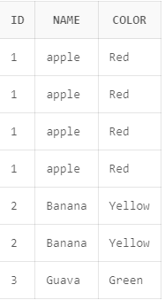

3. INNER JOIN

SELECT table_a.id, table_a.name, table_b.color

FROM table_a

INNER JOIN table_b ON table_a.id = table_b.id;

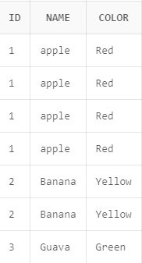

4. FULL OUTER JOIN:

SELECT table_a.id, table_a.name, table_b.color

FROM table_a

FULL OUTER JOIN table_b ON table_a.id = table_b.id;

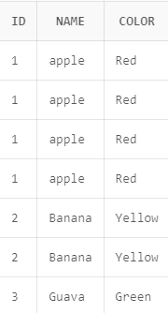

5. CROSS JOIN:

SELECT table_a.id, table_a.name, table_b.color

FROM table_a

CROSS JOIN table_b;

